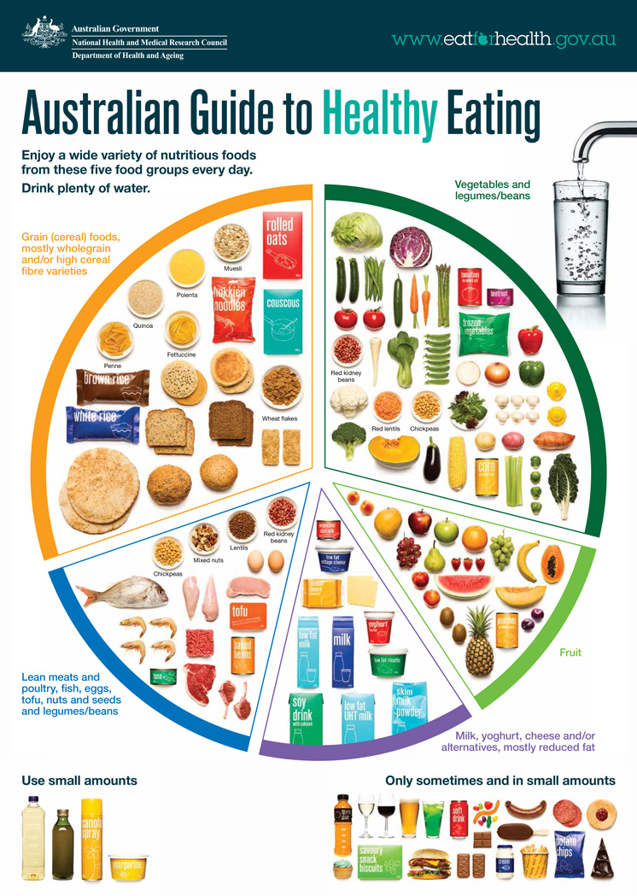

This guide is showing the amounts of different types of foods and proportions that we need to have to stay healthy the healthy population aged over 2 years

The strengths of this model is that its easy to understand and interpret

The weakness of this model is that it's over simplifying things and doesnt give the hole picture